

PHR 2/3 Reporter
August 2022
All New!
Public Health Region 2/3
Texas Department of State Health Services
  Inside This Issue  Introductory Greetings 1  Program Updates 2  TEPHI Conference 3  PHR 2/3 Job Postings 3  Committee Updates 4  Critters’ Corner 4  “No Worry Introductions” 5  Work Anniversaries 6  Team Member Updates 6  AND MORE! | What Has Becky Been Up To?  Becky Earlie-Royer, Deputy Regional Director  For the past couple of months, it has been busy here in the region as we started up two new teams- Assessment Evaluation and Outcomes team (Reg Admin) and the Youth-Based Behavioral Health Team (CHI). The region also on-boarded the new positions of the Regional Communications Specialist (Reg Admin) and Behavioral Health Coordination Specialist (PHEPR). These teams and positions are new to the region so as the team members are on-boarded, we are also developing their operational framework-essential job functions. Over the past several months, we have also welcomed two new members to the region’s leadership team- Regional Medical Director and PHEPR Program Manager- and working on hiring a third- CHI Program Manager. In the midst of all of this, I have also been taking time away each month to have overdue visits with family, reconnect with my hobbies and have a chance to check-in mentally and physically on how I am are doing after 2.5 years of surviving a pandemic. These breaks have allowed me to remember who I am, reset my mental and physical health and rekindle the passion I have about working in the field of public health. As we get ready to begin a new fiscal year….please remember to take care of yourself…you are not replaceable!  .  Greetings from Dr. Schmalstieg  Dr. Aurelia Schmalstieg, Regional Medical Director  Happy August to everyone! This is an exciting time of year when we look forward to the new school year, enjoy the expectation of cooler weather (which will hopefully come soon), and prepare for a new fiscal year. This year, with the arrival of August also comes our first edition of the re-boot of our monthly regional newsletter. We hope this newsletter will improve communication among the different departments and administration, celebrate our work and achievements, and maybe even add a little humor to everyone’s day. We won’t be able to create a successful newsletter each month without your contributions! In order to get the best content we will be asking for input from each manager every month, and there will also be opportunities to submit your ideas and kudos directly to Christopher Currie, our new Regional Communications Specialist. He is going to be putting the newsletter together each month, and has some great ideas about how to develop this into a great resource for the region. I wish you all the best and hope this month brings good things for you and yours as we look forward to the beginning of Autumn.

PROGRAM HIGHLIGHTS

Epidemiology
New academic publications in the latest edition of American Journal of Infection Control feature our own Heidi Honza, David Retana, Gerline Casseus, and Scott Mize as co-authors. Congratulations, all!
https://www.ajicjournal.org/article/S0196-6553(22)00300-5/fulltext
https://www.ncbi.nlm.nih.gov/pmc/articles/PMC9215237/
Heidi and David also co-authored the abstract on a C. auris outbreak in Collin County. 😊
https://www.ajicjournal.org/article/S0196-6553(22)00265-6/fulltext

Public Health Nursing
Public Health Nursing would like to welcome Melodie Short, Community Specialist (Cleburne), Rita Davidson, Community Specialist II (Abilene) and Cassandra Bullock, LVN (Gainesville) to the PHN Team. We are so glad you are here!
The PHN Team is in the throes of back-to-school immunization clinics preparing children to safely return to school with routine immunizations. The individual field office teams are also planning for community outreach activities including flu vaccination clinics and car seat events.

Specialized Health & Social Services
PHR 2/3 SHSS program employees attended the statewide 2022 SHSS Conference in Corpus Christi earlier this month. During the conference, several employees were presented with award certificates for their exceptional contributions to the program: Stephanie Wegner, Initiative Award; Bill Barber, Team Player Award; Janel Hendricks, Outstanding Contributor Award; Ellen Ellis, Flexibility Award.

Emergency Preparedness & Response
The West Central Texas Emergency Preparedness Conference will take place on September 28th, 2022 in Abilene, TX. Members of PHR 2/3 will be presenting on topics including Disaster Mental Health/Resources, POD Planning & Support Considerations, and more. The PHEPR Team supported this event. The conference is to bring PHR-2’s emergency management and preparedness stakeholders together for discussion, networking, and education on issues of common concern and interest in the West Central Texas area on natural and man-caused disasters and hazards.

Community Health Improvement
As of the beginning of July – the CHI Behavioral Health Team is fully staffed!
On July 16th the National Suicide Prevention Hotline short dial code 988 went live. Individuals can either call or text 988 to be connected to a trained crisis center worker.

Program Manager Meeting
Trending Topics
Requests for conference registrations, development training and retirement gifts for FY2022 are due by August 19th.

Copier supplies- In Arlington office, copier supplies are located in the Regional Administration area. Signage has been posted at the copying areas indicating the location of the supplies. Team members will need to let Regional Administration know what the copier model is to get the correct supplies.

Out of State Travel Assignment- There is no update from RLHO on the status of the assignment. Managers will be informed as soon as RMD/DRD receives information.

Program Managers were asked to remind team members to enter all time scheduled for leave in August in CAPPS as soon as possible for their approval by August 30, 2022. This will ensure time taken for annual leave are deducted prior to the FY2023 annual leave to sick time conversion.

Ensure you are certifying monthly time prior to the deadline to avoid late emails being sent to leadership. Helpful Tip: Recurring calendar invite as a reminder (i.e., first Friday of each month).

Program managers were asked to review the dress code guidance at the next program team meeting. A work group to examine the potential of programs sharing rental cars for cost and operational efficiency will convene for discussion.

DSHS PHR 3’s weekly monkeypox operational meeting was held.
PHR 2/3 Reporter

Page 2

Page 2
  PHR 2/3 JOB POSTINGS  Arlington  Sanitarian I  Program Specialist III  Public Health and Prevention Specialist III  TB Epidemiologist  Social Worker II  CSHCN Services Program Eligibility Specialist  Healthcare-Associated Infections Epidemiologist II  Public Health and Prevention Specialist III  Manufactured Foods Sanitarian I  Abilene  Inspector V  Public Health and Prevention Specialist II  CSHCN Services Program Eligibility Specialist  Regional Community Engagement Specialist  Archer City  Public Health Nurse I  Wichita Falls  Public Health Educator II  Disease Intervention Specialist  STD Surveillance Administrative Assistant  Gainesville  Public Health Nurse I  For further information you may contact the Access HR Service Center at (888) 894-4747  TEPHI CONFERENCE WRAP-UP  The Texas Public Health Summit took place on July 14th, 2022. The topic was Fostering Trust Through Effective Communication. The Texas Epidemic Public Health Institute has published the full conversation on TEPHI's YouTube channel: Session 01 and Session 02. Additionally, a link to the transcript for the summit is available here. The summit was a great opportunity to examine best practices in public health communications outreach to stakeholders, concerning all the important issues that public health agencies address. | EDITOR’S NOTE:  Hi folks! I hope everyone enjoys this reboot of our monthly newsletter! If you have any suggestions for an article or segment, email me at Christopher.Currie@dshs.texas.gov. Looking forward to hearing from you! Thanks for all that you do!  Chris Currie
Program Manager
September Meeting Agenda Items
- DSHS PHR 2/3 Internal Communication Strategic Plan
- DSHS PHR 2/3 Situational Telework Discussion
- DSHS PHR 2/3 Educational Leave Guidance
- DSHS Transition to Qualtrics

PHR 2/3 Reporter

Page 3

Page 3

The pets in this month’s spotlight are a pair of cats named Satin and Denim, submitted by
Dr. Schmalstieg. She says that their favorite summer activities are playing with bugs 
and licking ice cubes!  

We love our pets!
Be they furry or feathered, finned or flying, feline or canine, scaly or slimy, equine or bovine, if you have a pet that you’d like to showcase on Critters’ Corner, feel free to send an email!
Christopher.currie@dshs.texas.gov
CRITTERS’ CORNER

Page 4
PHR 2/3 Reporter

  A Primer on Sun Exposure  Adapted from a CDC blog on Travelers’ Health:  The sun’s ultraviolet (UV) rays are harmful. When exposure is prolonged you’re at risk for issues like sunburns but also sun damage and skin cancer. Protect yourself from the sun with the following tips:  Use Sunscreen: Sunscreen protects you from sun exposure by reflecting or absorbing UV rays. Use sun protection factor (SPF) 15 or higher. Look for “blocks UVA and UVB” or “broad spectrum” on the label. Reapply at least every 2 hours and when you get out of water or sweat heavily. If you use bug repellent, apply sunscreen first. Follow instructions for how often you need to reapply the repellent and sunscreen. Throw away containers of sunscreens after 1–2 years.  Wear Protective Clothing: Wear clothing to cover as much skin as possible. Use hats with a wide brim to shade your entire head/neck area. Wear sunglasses that block both UVA/UVB rays. Stay in the shade, especially during midday. Drink plenty of non-alcoholic beverages like water. Avoid indoor tanning facilities.  Treating Sunburn: Take aspirin, acetaminophen, or ibuprofen to relieve pain, aches, and fever. Drink plenty of water. Soothe burns with cool baths or apply cool, wet cloths. Use moisturizing cream. Don’t return to the sun until the burn has healed. Seek medical attention for a severe sunburn, if it covers over 15% of your body, if you’re dehydrated, have a high fever, or are in extreme pain that lasts more than 48 hours.  Workforce Committees  Wellness Committee:  An informational meeting on September 14 at 10 am will be in Conference Room 2210 or on TEAMS here. Please contact the Wellness Committee with any questions by emailing PHR2/3WellnessCommittee@dshs.texas.gov.  Safety Committee:  If you are safety conscious or have any suggestions on ways to improve current procedure(s) in place, then you are encouraged to join the Safety Committee via email to HSR23.Safety@dshs.texas.gov.  Health Disparities:  Please check out the Health Disparities bulletin board in the hallway by the large breakroom. For more information, please contact Rhonda London at Rhonda.London@dshs.texas.gov.  Diversity Committee:  Anyone is welcome to attend and to bring their ideas. Please contact team lead Amber Portis at Amber.Portis@dshs.texas.gov or 817-264-4623. |  | 
  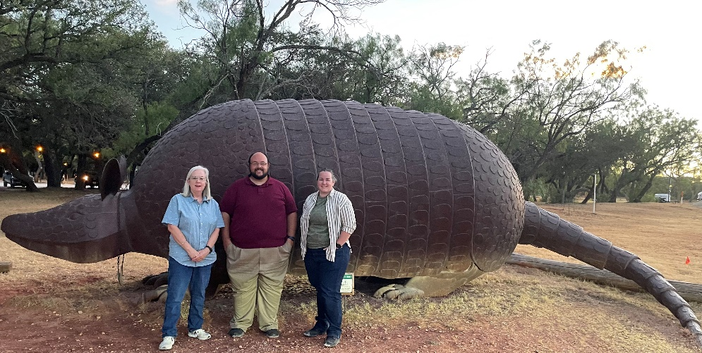   | NO WORRY INTRODUCTIONS | Introduce Yourself with Confidence  Many of us dread the self-introduction, whether it’s in an online meeting or at a boardroom table. The secret to introducing yourself with confidence, in any context, is a simple three-step process: Focus on your present, past, and future.  Present. Start with a present-tense statement to introduce yourself. Your name and job title are a great place to start. If there’s an opportunity to elaborate, you can also share other details such as a current project, your expertise, or your geographical location.  Past. Add two or three points that will provide relevant details about your background and credibility. Consider your education, past projects, employers, and accomplishments.  Future. Demonstrate enthusiasm for what’s ahead. If you’re in a job interview, share your eagerness about potential opportunities at the company. Or, if you’re in a meeting, express interest in what the team is setting out to accomplish.  This tip is adapted from “A Simple Way to Introduce Yourself,” by Andrea Wojnicki  HOW COOL  Zoonosis Team members Dr. Shelley Stonecipher, Kelsey Tatum and Nick Ferguson were conducting county outreach in Buffalo Gap, and the armadillo statue is at a restaurant in town! Fun Fact: There are around 20 known species of armadillo, but only one is found in the USA.

Page 5
PHR 2/3 Reporter

Late Summer Lemonade Recipe
Adapted from Love & Lemons blog
ingredients/instructions:
Start with 1 cup simple syrup: 1 cup water, 1 cup sugar. Simmer until sugar dissolves, strain and chill. Add ½ cup of mint or basil and allow to steep for 15 minutes for a nice twist.
Bag of lemons (5-6 lemons makes approx. 1 cup of juice): Halve and squeeze lemons until you have 3 cups of lemon juice (or less to scale-down).
Combine everything: pour lemon juice, syrup and water into a pitcher and add some handfuls of ice.
Lastly, taste and adjust. For a sweeter taste, add more simple syrup. To enhance the tartness, add more lemon juice.
Pour into glasses filled with ice and top as desired: lemon/lime wedges, strawberries, blueberries, sprigs of mint, etc.





TEAM MEMBER UPDATES!

Page 6
Region 2/3 Reporter

AUGUST WORK ANNIVERSARIES
Happy anniversary to the following team members of PHR 2/3! Kudos!
- Liam Peterson (1 year)
- Connie Cortes (7 years)
- Ellen Ellis (9 years)
- Allie LaCombe (10 years)
- Dr. Shelley Stonecipher (16 years)

HAPPY RETIREMENT!
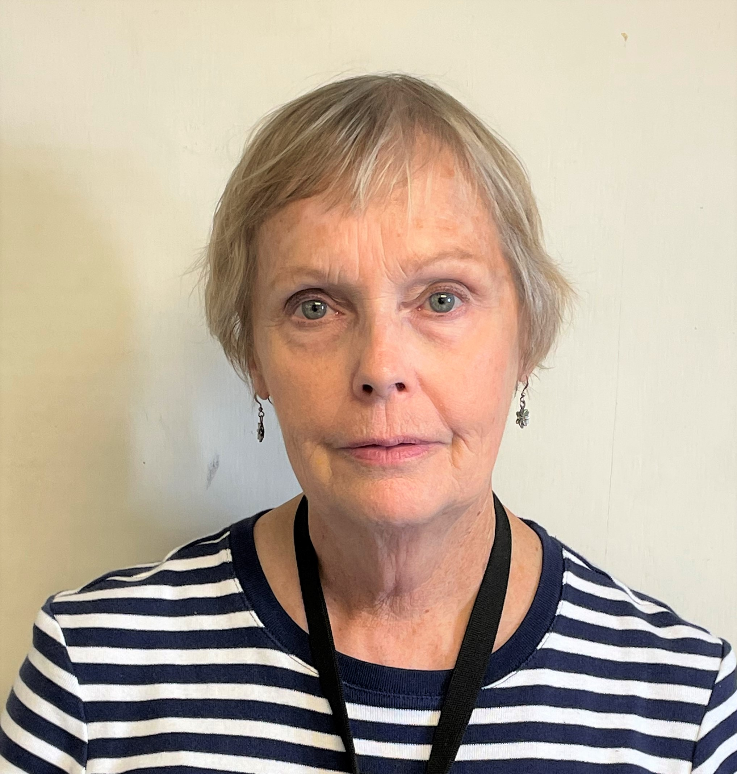
Congratulations to Kristin Tofflemoyer, Community Specialist in the Cleburne Field office on her upcoming retirement on August 31, 2022. Kristin has been a DSHS employee for 21 years. Kristin will be greatly missed, but we want to wish her the very best in the next chapter of her life journey!

PHOTOS FROM SHSS CONFERENCE IN CORPUS CHRISTI
KUDOS TO ALL THE TEAM MEMBERS!
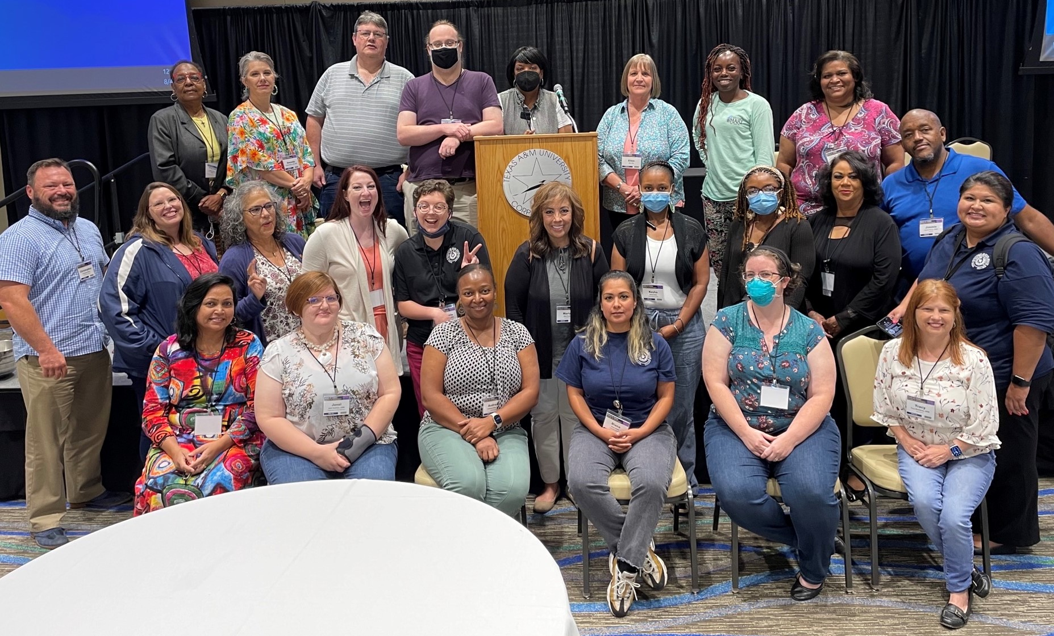
PHOTOS FROM SHSS CONFERENCE
IN CORPUS CHRISTI, CONTINUED
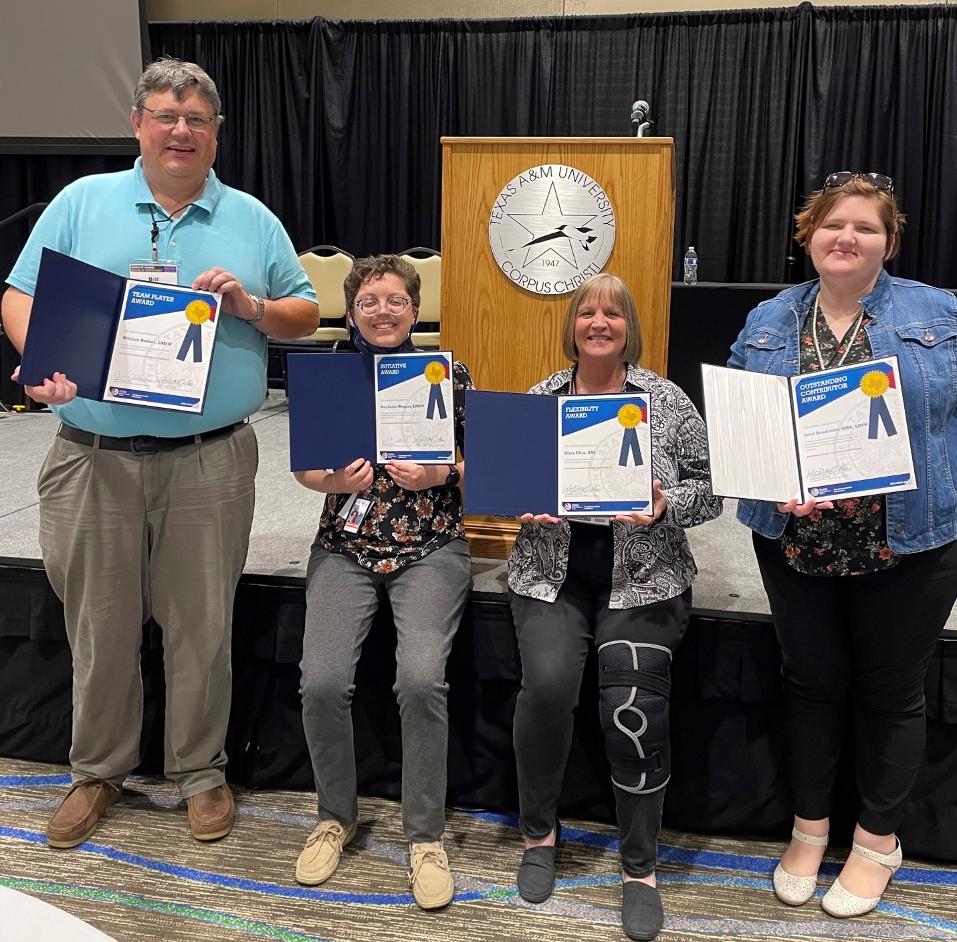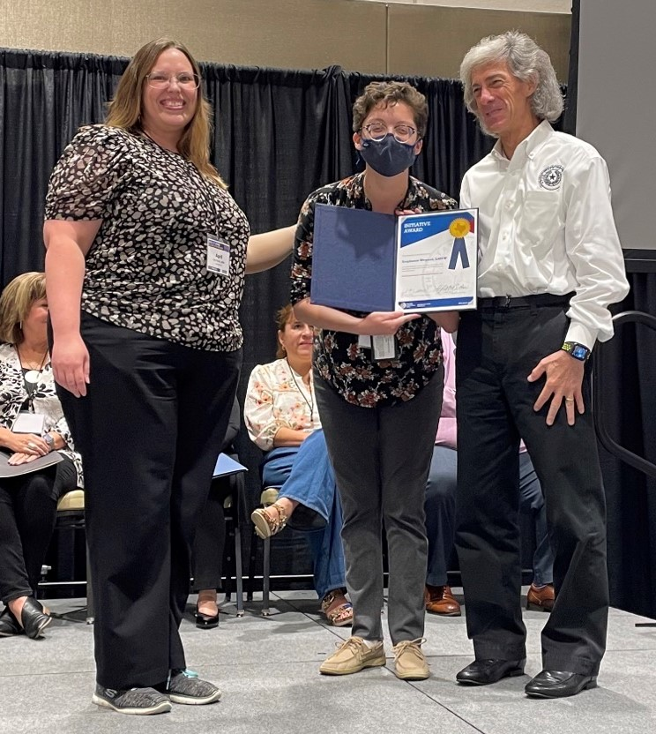

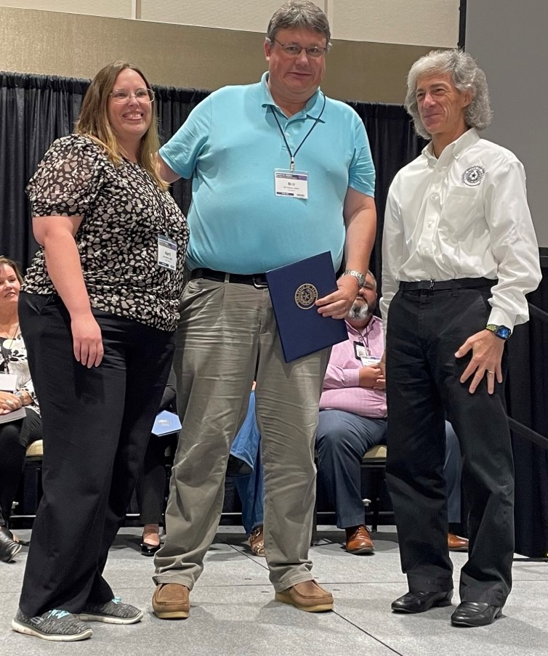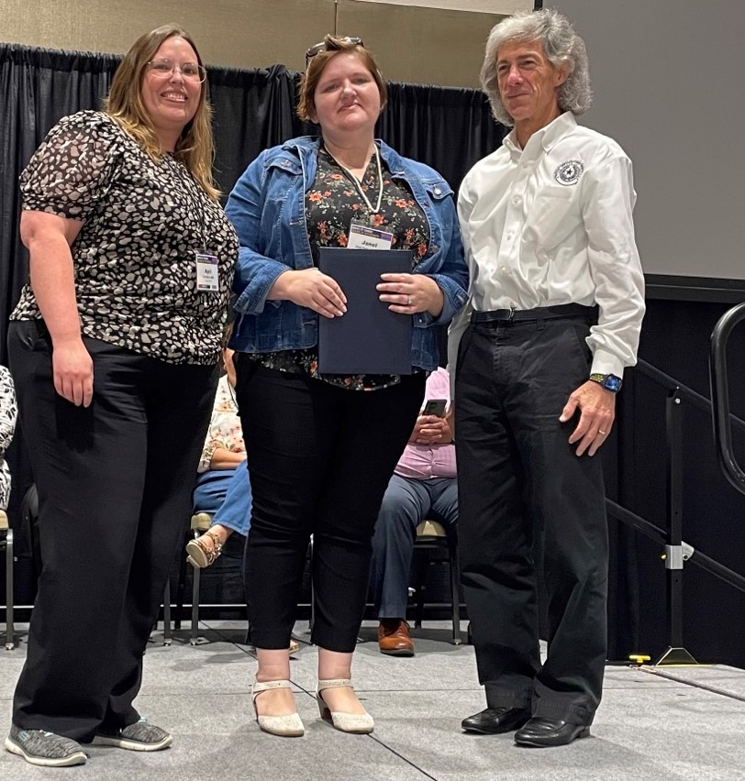

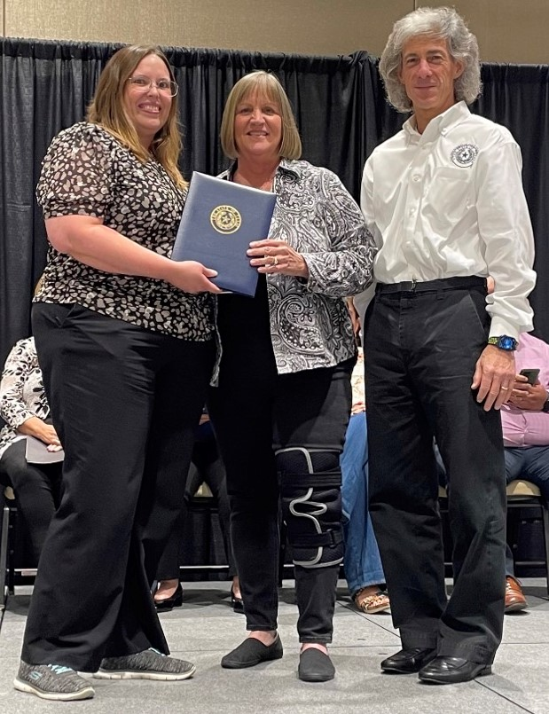


EDITOR’S NOTE:
Hi team! We can reserve this space for special acknowledgements of all kinds for our team members. Earn a certificate? A college degree? A child’s wedding? Your wedding? Welcomed a new child/grandchild? Feel free to email me at Christopher.Currie@dshs.texas.gov.
See you in September!

